**DAILY ONLINE ACTIVITIES SUMMARY**

|  |  |  |  |  |
| --- | --- | --- | --- | --- |
| **Date:** | 17/07/2020 | **Name:** | JASLINE SHARON TAURO | |
| **Sem & Sec** | 4th sem,  A Section | **USN:** | 4AL18CS029 | |
| **Online Test Summary** | | | | |
| **Subject** | DATA COMMUNICATION | | | |
| **Max. Marks** | 30 | **Score** | N/A | |
| **Certification Course Summary** | | | | |
| **Course** | Data Scientist | | | |
| **Certificate Provider** | AWS | **Duration:** | | 4 hrs |
| **Coding Challenges** | | | | |
| **Problem Statement:** Reverse words in a given String in Python We are given a string and we need to reverse words of given string? | | | | |
| **Status:** | | Executed | | |
| **Uploaded the report in GitHub** | | YES | | |
| **If yes Repository name** | | <https://github.com/jaslinesharontauro/Python-coding> | | |
| **Uploaded the report in slack** | | YES | | |

**ONLINE TEST DETAILS:**

**Today we had assessment in the subject “DATA COMMUNICTAION”. The test was conducted based on first module of this subject. The test was of descriptive type and was comprised of 4 questions.**

**CERTIFICATION COURSE DETAILS:**

## Today I continued the course“Data Scientist” by AWS. Today I learnt about Data structures, data warehouse, Relational and non-relational data structures. I also completed the assignments of this module.

#### 

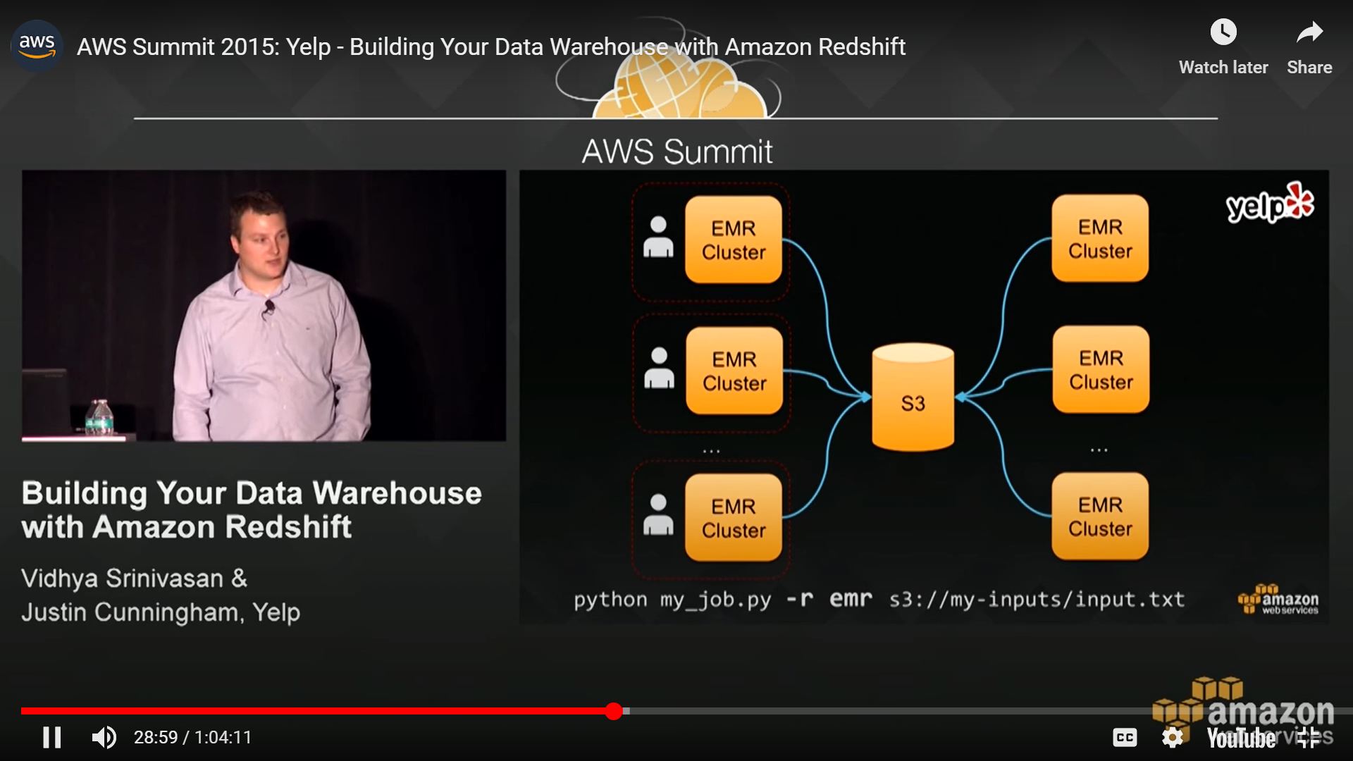

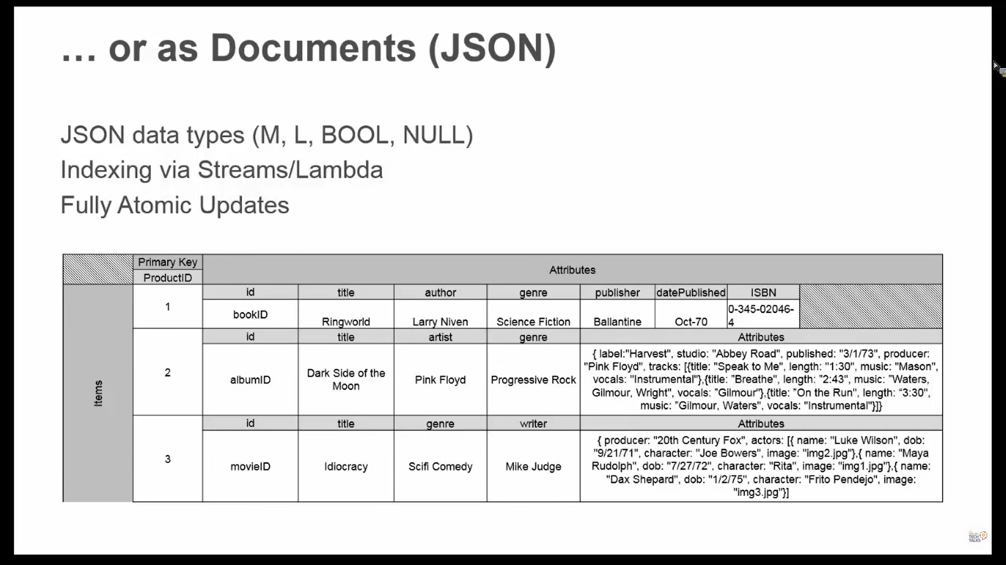

CODING CHALLENGES:

Problem Statement:

Reverse words in a given String in Python We are given a string and we need to reverse words of given string ?

Examples:

Input: str="AIET CHALLENGES IIT"  
Output: str = "IIT CHALLENGES AIET"

Solution uploaded in GitHub

